Nottingham City and Nottinghamshire
Suicide Prevention Strategy
2019-2023

Produced by Nottingham City and Nottinghamshire County Public Health, in partnership with Nottingham’s Suicide Prevention Steering Group and Nottinghamshire Healthcare NHS Trust, January 2019.
THIS SUICIDE PREVENTION STRATEGY IS AN UPDATE OF THE NOTTINGHAMSHIRE SUICIDE PREVENTION FRAMEWORK FOR ACTION 2015-2018, AND THE NOTTINGHAM CITY SUICIDE PREVENTION STRATEGY 2015-2018. THIS STRATEGY WAS DEVELOPED IN PARTERSHIP BY THE NOTTINGHAMSHIRE AND NOTTINGHAM CITY SUICIDE PREVENTION STEERING GROUP. PRINCIPAL CONTRIBUTORS INCLUDE:

Organisation | Name
Nottinghamshire County Council | Susan March
 | Catherine Pritchard
 | Jane O’Brien
Nottingham City Council | Jane Bethea
 | Ben Rush
 | Anna Masding
British Transport Police | Mark Clements
Nottinghamshire Police | Anthony Horsnall
Nottingham City CCG | Dr Marcus Bicknell
Newark and Sherwood CCG | Karon Glynn
NHS England | Elaine Woodward
 | Wendy Henson
Nottinghamshire Fire and Rescue Service | Chris Hooper
Nottinghamshire Healthcare NHS Trust | Rachel Lees
 | Faye Harrison Yuill
 | Marie Armstrong
University of Nottingham | Dr Ellen Townsend
 | Jo Lockwood
Nottingham Trent University | Karen Slade
Harmless | Bevan Dolan

Advice when reading this document:

If by reading and reviewing this strategy you become concerned about your own or someone else’s suicidal and self-harm thoughts or behaviour we advise that you speak to a trained health care professional by either:

- Making an appointment with your GP
- Telephoning the Samaritans on 08457 90 90 90
- Telephoning Cruse Bereavement Care on 0844 477 9400

Contents

Table of Contents
Contents 5
1.0 Executive Summary 7
2.0 Introduction 10
3.0 History of the Strategy 11
4.0 Policy Context 12
4.1 National Drivers 12
4.1.1 National Strategy and its updates 12
4.1.2 Health Select Committee Inquiry and Government response 14
4.1.3 NHS Long Term Plan 16
4.1.4 Targets and Outcomes frameworks 16
4.1.5 Wider mental health strategies 17
4.1.6 Professional bodies and evidence-based guidelines 17
4.1.7 Other reports 19
4.2 Local Drivers 21
4.2.1 Health and Wellbeing strategies 21
4.2.2 Mental Health Trust strategy 21
4.2.3 Nottingham and Nottinghamshire Integrated Care System Mental Health and Social Care Strategy (2019-2024) 22
5.0 Definitions of suicide and self-harm 22
5.1 Suicide 22
5.2 Self-harm 23
6.0 Factors associated with suicide 23
6.1 Risk factors for suicide and self-harm 23
6.2 Other factors associated with suicide and self-harm 25
6.3 Mental health services and suicide 27
6.4 Offenders and suicide 27
6.5 Risk factors specific to self-harm 28
6.6 Rates of self-harm 28
6.7 Protective factors 29
7.0 Suicide rates and trends 29
7.1 National data 30
7.1.1 National and regional trends 30
7.1.2 Suicide rate by age and gender 31
7.2 Local data 32
7.2.1 Suicide rate and deprivation 32
7.2.2 Suicide rate and gender 33
7.2.3 Methods of suicide and self-harm 34
7.2.4 Ethnicity 35
8.0 Progress since the previous strategy 36
9.0 Strategy aims and priorities 38
9.1 Overall aim 39
9.2 Strategic priorities 40
9.2.1 Priority 1: At-risk groups 41
9.2.2 Priority 2: Use of data 41
9.2.3 Priority 3: Training and bereavement support 41
9.2.4 Priority 4: Staff training 41
9.2.5 Priority 5: Media 42
9.3 Monitoring Outcomes 42
10.0 Taking the Suicide Prevention Strategy forwards 42
10.1 Leadership and governance 42
10.2 Suicide Prevention Strategy action plan 43
10.3 Equality Impact Assessment 53
11.0 Appendices 53
Appendix A: Local Policy Drivers 53
12.0 REFERENCES 55

Executive Summary

In England, approximately one person dies every two hours as a result of suicide.¹. Suicide has a significant, lasting and often devastating impact - economically, psychologically and spiritually - on individuals, families, communities, and the wider society. While accurate costs are difficult to quantify, national estimates suggest that each suicide costs the economy in England around £1.67 million.²
The causes of suicide are complex, and no strategy can be expected to completely remove all risk. However, there is much that can be done to ensure that we reduce this risk, and ensure that support is available for those at their most vulnerable.
Suicide rates tend to vary over time. They reached an historical low in 2007, before increasing in the years to 2014. There has been an encouraging reduction in suicide rates since, and the overall rate in England is now at its second lowest recorded level: from 16.0 per 100,000 in 2014 to 14.0 in 2017. Historically, Nottingham City has had a higher rate of suicide than the England average. Although in recent years the rates in Nottingham City and Nottinghamshire have both lowered, there is significant fluctuation, and the most recent figures are again above the national average rate.
There are many well-recognised risk factors and at-risk groups for suicide. There is a notable socio-economic gradient, with those in the poorest group subject to 10 times the risk of suicide than those in the most affluent group.³ Men are also at significantly higher risk, accounting for around three quarters of all suicides (3,328 out of 4,451 suicides in England were males in 2017). Suicide remains the biggest killer of men under 50, and is a leading cause of death in young men. Self-harm is another recognised risk factor for suicide, with UK studies estimating that in the year after an act of deliberate self-harm, the risk of suicide is 30–50 times higher than in the general population. Non-fatal self-harm leading to hospital attendance is the strongest single risk factor for completed suicide.
Suicide prevention goes hand in hand with addressing these risk factors, both at an upstream, population and life-course level, and at a targeted, risk group level. This strategy outlines the ways in which Nottingham City, Nottinghamshire County, and their local partners aim to work towards a reduction in suicides and self-harm amongst the local population. This is in line with the national target of a 10% reduction by 2020/21, as cited by the national suicide prevention strategy for England,¹ the national mental health strategy,⁴ and the new NHS Long Term Plan,⁵ among others.

Overall aim of this strategy:
To reduce the rate of suicide and self-harm in the Nottingham City and Nottinghamshire population, by proactively improving the population mental health and wellbeing, and by responding to known risks for suicide in the population.
The following priorities have been identified as the local key areas for action:

Priority 1: At-risk groups
Identify early those in groups at risk of suicide, and ensure they have access to evidence-based interventions, paying particular attention to:
- Men, including men in contact with or in transition through the criminal justice system.
- Children and young people, including university students.
- Self-harm as a risk factor.

Priority 2: Use of data
Collect and review suicide and self-harm data in a timely manner, using it to inform local practice, particularly via real-time surveillance

Priority 3: Bereavement support
Ensure the availability of prompt bereavement support for those affected by suicide.
Priority 4: Staff training
Provide effective training for frontline staff to recognise and respond to suicide risks.
Priority 5: Media
Foster close engagement with media personnel to ensure that suicide and suicidal behaviour are reported with sensible, sensitive approaches.

Prevention of suicide calls for working across sectors at local and national level. There is need to tackle all the factors which may increase the risk of suicide and self-harm in the communities where they occur, if our efforts are to be effective. Suicide prevention is most effective when it is addressed across the life course and when combined with wider prevention strategies that address improving the mental health and wellbeing of the population and the wider determinants that impact on health, such as employment, low income and housing.

Introduction

Suicide refers to the act of intentionally taking one’s own life. It is a sensitive issue, as well as a highly complex one: in its contributory factors, its impact, and its very interpretation. Today, suicide is rightly seen as a serious and significant public health issue. Worldwide, across all ages, sexes and populations, suicide ranks as the tenth most common cause of death. Throughout our lifetimes, around one person in fifteen will make at least one suicide attempt.⁶ While the number of people who take their own lives in England has gradually reduced in recent years, the overall numbers are still very significant. Between the years of 2003-2013, 18,220 people in the UK took their own lives; nearly 6,000 suicides were recorded in 2017 alone. Three quarters of suicides are male, and for men aged 20-49 in England and Wales, it is the single most common cause of death.⁶
The impact of a suicide, be it completed or attempted, cannot be underestimated. It is sadly unique in the immeasurable and long-lasting pain, suffering and loss it causes to individuals, families and communities. This psychological burden is borne not only by those at risk of or attempting suicide, but by their loved ones as well. There are also significant wider economic and societal costs associated with both attempted and completed suicide; the cost of a completed suicide in the UK has been estimated at over £1.6 million. ^{1,7–10}
Self-harm describes somebody intentionally damaging or injuring their own body. It is closely related to suicide, but is a distinct entity in its own right: there is often a history of self-harm in completed suicides, but not all those who self-harm will attempt suicide, and not all completed suicides will have a history of self-harm.^{2,7,11} Some self-harm is driven by the desire to take one’s own life, but self-harm can also be a way of coping with, or expressing, overwhelming emotional distress.^{12,13} Both suicide and self-harm are very closely linked to mental distress. Self-harm is one of many well-recognised risk factors for suicide, although mental health disorders in general are the most common and significant risk, with up to 90% of people taking their own lives suffering from such a disorder. As well as this, there are also wider personal, social and environmental stressors, including substance abuse and genetics.¹²
Despite the size of the problem, its tragic cost, and its inherently preventable nature, efforts to address suicide are not always well-recognised or supported. There remains significant stigma, often contributing a lack of willingness to engage. For these and other reasons, preventing suicide is well acknowledged to be a complex challenge.¹⁴
Suicide prevention strategies are a means by which organisations and partnerships can set out their commitment and intent towards reducing suicide rates in a defined population. This strategy is intended to outline our local approach to suicide prevention. It applies to all ages and all groups. It recognises not only the difficulties, but the opportunities that exist and the contributions that can be made across all sectors of society. The strategy draws on local experience and expertise, as well as on national policy, research evidence, and guidance.

History of the Strategy

In recent decades, suicide prevention has developed considerably as concerns around suicide rates have intensified. In England, since September 2012, there has been an integrated national Government strategy, Preventing Suicide in England: a cross-government outcomes strategy to save lives.¹ This built on a previous Government strategy, established in 2002, which was more limited and in particular did not acknowledge the need to operate at a cross-Government level.
In 2009, Nottinghamshire County, Bassetlaw and Nottingham City Primary Care Trusts (PCT) produced a joint suicide prevention strategy for the period 2009-2012. This placed emphasis on achieving the prior Our Healthier Nation target of reducing suicide by one fifth by 2010.
In 2015, Nottingham City and County Councils each produced individual but jointly-researched Suicide Prevention Strategies (2015-2018).^{15,16} These strategies both included the same five priority areas for action to reduce the incidence of suicide.
This 2019-2023 strategy provides an update on the previous strategy, and drives the ongoing suicide prevention work which has been carried out across Nottingham and Nottinghamshire since 2009, while reflecting new and updated priorities and guidance.
The Nottinghamshire and Nottingham City Suicide Prevention Steering Group oversees the strategy and implementation of its associated action plan. This multi-agency steering group includes representation from Nottinghamshire County and Nottingham City Public Health, Clinical Commissioning Groups (CCGs), children and adults mental health services (CAMHS), health and social care, HM Coroner’s Service, police, fire and ambulance services, Network Rail and third sector organisations with a remit in suicide prevention and support.
The Steering Group, and this strategy, form a part of the Nottinghamshire Integrated Care System (ICS); as such, they also sit within the ICS’ Strategy (see section 4.2.3), and will report to the ICS Board through the ICS Mental Health and Social Care Board.

Policy Context

4.1 National Drivers

4.1.1 National Strategy and its updates

Prior to 2012, suicide prevention initiatives in England centred on health policy and were directed through the Department of Health, including the white papers Modernising Mental Health Service (1998); Saving Lives: Our Healthier Nation (1999); and the National Service Framework for Mental Health (1999). The first National Suicide Prevention Strategy for England was produced in 2002.
Preventing suicide in England: A cross-government outcomes strategy to save lives¹ was published in 2012. This was an all-age suicide prevention strategy, building on the 2002 work. The strategy supports actions by bringing together knowledge about groups at higher risk of suicide, applying evidence of effective interventions and highlighting resources available. Crucially, it was the first to explicitly acknowledge the importance of cross-Government working, stating that
“Suicide is often the end point of a complex history of risk factors and distressing events; the prevention of suicide has to address this complexity. This strategy is intended to provide an approach to suicide prevention that recognises contributions that can be made across all sectors of our society.”
The strategy’s key objectives and action areas aimed to define what the strategy as a whole intends to achieve. These objectives and actions are outlined in Box 1:

Box 1: National suicide prevention strategy key objectives and areas for action
Key Objectives
- Reduce the suicide rate in the general population of England
- Offer better support for those bereaved or those affected by suicide
Key areas for action
Action area 1 - Reduce the risk of suicide in key high-risk groups.
Action area 2 - Tailor approaches to improve mental health in specific groups.
Action area 3 - Reduce access to the means of suicide.
Action area 4 - Provide better information and support to those bereaved or affected by suicide.
Action area 5 - Support the media in delivering sensitive approaches to suicide and suicidal behaviour.
Action area 6 - Support research, data collection and monitoring

The first annual report, Preventing Suicide in England: one year on (2014)¹⁷ set out the developments since the launch of the 2012 national prevention strategy, and highlighted areas where more work was felt to be needed. The messages in this report were designed to help local areas focus on the most effective things that they can do to reduce suicide.
The second report, Preventing suicide in England: two years on (2015)¹⁸ highlighted work that was being conducted to prevent suicides and set out priorities for the following year. It noted in particular the rise in suicides among prisoners and younger age groups, despite a gradually decreasing trend overall.
The third progress report for the national strategy, Preventing suicide in England: Third progress report of the cross-government outcomes strategy to save lives (2017)¹⁹ articulated a commitment to strengthen the Government’s response to suicide, and provided some response to the Health Select Committee interim report on suicide prevention. It specifically pledged to “put in place a more robust implementation programme to deliver the aims of the National Strategy”, particularly at the local level, by committing every area to produce a multi-agency suicide prevention plan. This Progress report highlighted, as a priority for renewed focus, patients who are commonly identified as being at higher risk of suicide by ensuring safe treatment in community settings and investing in liaison mental health services in acute hospitals. There was also a new focus on support for bereaved families as well as on education and young people’s mental health. It added a commitment to the national strategy to reduce the rate of suicides by 10% by 2020/21 nationally, as compared to 2016/17 levels.
The third progress report highlighted several specific high-risk groups, although this was in the context of priority groups and groups of interest, rather than an objective list of highest risk. The highlighted groups included:
- Young and middle-aged men
- People in the care of mental health services
- People in contact with the criminal justice system
- Specific occupational groups (doctors, nurses, veterinary workers, farmers and agricultural workers)
- People with a history of self-harm
The fourth and most recent progress report, Preventing suicide in England: Fourth progress report of the cross government outcomes strategy to save lives,²⁰ was published in January 2019. This reaffirmed the importance of suicide prevention as a national priority, including within the new NHS Long Term Plan ,⁵ also published in early 2019. It noted the recently-announced national investment in suicide prevention, the importance of local multi-agency suicide prevention groups, and the overall reductions in suicides, such that the last two years have seen the biggest reduction in England in the past decade. It also noted the establishment of the new National Suicide Prevention Strategy Delivery Group. The following priority areas were outlined:
- Working in partnership with local government to embed their local suicide prevention plans in every community
- Delivering the ambition for zero suicide in mental health inpatients and improving safety across mental health wards and extending this to whole community approaches
- Addressing the highest risk groups including middle-aged men and other vulnerable groups such as people with autism and learning disabilities, and people who have experienced trauma by sexual assault and abuse
- Tackling the societal drivers of suicide such as indebtedness, gambling addiction and substance misuse and the impact of harmful suicide and self-harm content online
- Addressing increasing suicides and self-harming in young people
- Improving support for those bereaved by suicide

4.1.2 Health Select Committee Inquiry and Government response

The House of Commons Health Select Committee (HSC) conducted an inquiry into suicide prevention in England during late 2016 and early 2017. In anticipation of the publication of the Government’s Third Progress Report, the HSC published an interim report in December 2016, Suicide Prevention: Interim Report, Fourth report of Session 2016-17.²¹ The HSC hoped that this would allow the Government to “take (its findings) into account before drawing its final conclusions”. The Interim Report highlighted five areas it believed ought to be key to the Government’s considerations:
- Implementation. A clear implementation programme underpinned by external scrutiny.

- Services to support people who are vulnerable to suicide. This would include wider support for public mental health and wellbeing; identification of and targeted support for at-risk groups; early intervention services; access to help in non-clinical settings; improvements to both primary and secondary care; and services for those bereaved by suicide.

- Consensus statement on sharing information with families. This relates to better training of professionals to ensure that opportunities to involve families or friends in a patient’s recovery are maximised where appropriate.

- Data. Timely and consistent data are needed to enable swift responses to suspected suicides and to identify possible clusters, in order to prevent further suicides.

- Media. Media guidelines relating to the reporting of suicide are being widely ignored; greater attention must be paid to dealing with breaches by the media, at national and local level. Consideration should also be given to what changes should be made to restrict access to potentially harmful internet sites and content.

Following the publication of the third progress report,¹⁹ the HSC published its full inquiry report in March of 2017, Suicide prevention. Sixth Report of Session 2016–17.²² This responded to the Government’s recently updated Strategy, commenting as follows:
“The Government’s recent focus on suicide prevention and mental health is welcome and necessary. Whilst the Government recognised our work in their progress report, we were disappointed that our concerns were not fully addressed nor were all of our recommendations taken on board… We consider that there are further steps which could be taken to reduce suicide.”
The inquiry voiced particular disappointment that its recommendation of all discharged inpatients receiving follow-up care within three days was not adopted. The Interim Report’s five key areas for consideration were re-stated, and a further two were added:
- Self-harm. the HSC welcomed the Third Progress report’s inclusion of self-harm prevention and recommended that “all patients who present with self-harm must receive a psychosocial assessment in accordance with NICE guidelines” and that “patients who present at A&E with self-harm should have a safety plan, co-produced by the patient and clinician, and properly communicated and followed up.”

- Support for those bereaved by suicide. The HSC further emphasised this area, deeming it appropriate to be incorporated into the renewed Strategy, and recommending that “ensuring high quality support for all those bereaved by suicide should be included in all local authorities’ suicide prevention plans”, and which should abide by basic standards.
While the Inquiry report made clear that the Strategy could be improved in many areas, it also highlighted that its key issue was “not with the strategy itself, but with ensuring effective and consistent implementation across the country”, and to this effect recommended a national implementation board be created.
The HSC also raised concerns that the Information Sharing and Suicide Prevention Consensus Statement²³ had not been promoted well and was being underused. This Statement was developed in 2014 to encourage sharing of information about those at risk of suicide between healthcare professionals and a patient’s family members and friends.
The Government Response to the Health Select Committee’s Inquiry into Suicide Prevention² was published in July 2017 and contained specific responses to all recommendations. While it rejected the suggestion of a national implementation board, it did announce other governance arrangements, including creating an “Inter-Ministerial Group for Mental Health”, creating a cross-Whitehall Director General/Director level group to oversee the full Government mental health portfolio, and establishing a National Suicide Prevention Strategy Delivery Group.

4.1.3 NHS Long Term Plan

The NHS Long Term Plan,⁵ published in 2019, contains a number of ambitions around mental health and suicide reduction. In particular, it calls for:
- A new approach to young adult mental health services, including services for the student population, services focusing on suicide reduction, improving access to psychological therapies, and highlighting groups of students with specific vulnerabilities.
- Provision of a single point of access and timely, universal mental health crisis care for everyone within the next 10 years. This is to include post-crisis support for families and staff who are bereaved by suicide.
- A continuation of the reduction in suicide rates to meet the target 10% reduction by 2020/21.
- Keeping suicide reduction as an NHS priority over the next 10 years.
- Developing a new Mental Health Safety Improvement Programme, focusing on suicide prevention and reduction for mental health inpatients.

4.1.4 Targets and Outcomes frameworks

From April 2013, Public Health England (PHE) became the national agency for public health in a role designed to support local authorities, the NHS, and partners across England. It was assigned a national leadership role to support local areas to help improve outcomes in public health, including mental health and suicide prevention. From this point on, suicide was included as an indicator within the Public Health Outcomes Framework: Improving outcomes and supporting transparency,²⁴ which set out an overarching view for public health. The outcomes framework supports the overall national strategic objective of reducing the suicide rate, and it includes indicators designed to help to track progress against this.

4.1.5 Wider mental health strategies

The Department of Health report No health without mental health: A cross-government outcomes strategy for people of all ages,⁴ published in 2011, covered suicide and was key in supporting reductions in suicide amongst the general population, as well as those under the care of mental health services. The first agreed objective aimed to ensure that more people will have good mental health. The subsequent 2012 prevention strategy drew heavily on this report.
Healthy Lives, Healthy People: Our strategy for public health in England (2011)⁹ gave a new, enhanced role to local government and local partnerships in delivering improved public health outcomes. This document outlines that the local responsibility for coordinating and implementing strategic direction for suicide prevention from April 2013, became an integral part of local authorities’ new responsibilities for leading on local public health and health improvement. The prompts for local councillors on suicide prevention published alongside this strategy are designed as helpful pointers for how local work on suicide prevention can be taken forward.
The 2013 Annual Report of the Chief Medical Officer: Public Mental Health Priorities: Investing in the evidence was published in 2014. This report included a focus on the epidemiology of public mental health and the quality of the evidence base, ‘horizon scanning’ of innovation in science and technology, the economic case for good mental health and chapters outlining the importance of both treating mental health as equal to physical health and of focusing on the needs and safety of people with mental illness.

4.1.6 Professional bodies and evidence-based guidelines

National Institute for Health and Care Excellence (NICE) guidelines: Self-harm in over 8s: short-term management and prevention of recurrence,²⁵ and Self-harm in over 8s: longer-term management²⁶ – These are evidence-based clinical guidelines for professionals involved in the management of people who self-harm. The key recommendation areas across both these guidelines include:
- Improving awareness, respect, understanding and choice in the delivery of services to those who self-harm
- Offering a comprehensive psychosocial assessment of needs and risks for those who self-harm
- Coproducing care plans and risk management plans with those who self-harm
- Treating associated mental health conditions
National Institute for Health and Care Excellence (NICE) guidelines: Preventing suicide in community and custodial settings²⁷ – these are further evidence-based clinical guidelines for professionals, aimed at helping local services to identify and help at-risk groups and people, and to prevent suicides in places where it is currently more likely. Its key recommendation areas include:
- The formation, structure and governance of local multi-agency suicide prevention partnerships
- Multi-agency partnerships in the community
- Multi-agency partnerships specifically in residential custodian and detention settings
- Multi-agency suicide prevention strategies and action plans, in line with the national strategy recommendations
- Using data sources to gather and analyse suicide-related information
- Preventing and responding to suicide “clusters”
- Engaging in local awareness-raising
- Reducing access to methods of suicide
- Providing ongoing training
- Supporting those bereaved by suicide
- Reducing the potential harmful effects of media reporting of suicide
NICE are also developing a Suicide Prevention Quality Standard,¹¹ which is due to be published in September 2019. This standard covers means to reduce suicide and address the effects of suicide at a local level, in communities and custodial settings. In its draft form, it makes quality statements covering five areas: the organisation and operation of multi-agency suicide prevention partnerships; collaboration with local media; involvement of family and carers with at-risk patients; and bereavement support.
Public Health England (PHE) published Local suicide prevention planning: A practice resource²⁸ in 2016. This was guidance specifically developed for local suicide prevention planning. It provided guidance around establishing a local multi-agency suicide prevention group, completing a local suicide audit, and developing a local strategy and action plan which is based on the national strategy and local data. PHE has also more recently published guidance for local commissioners on how and why they can deliver support after suicide.
The report Why children die: death in infants, children, and young people in the UK,²⁹ published in 2014 by the Royal College of Paediatrics and Child Health, National Children’s Bureau and the British Association for Child and Adolescent Public Health, recommends national analysis to be completed on young people’s suicides.
and a concerted and sustained policy response “to the problem of violence and self-harm among Britain’s young people is needed urgently to address the lack of progress in reducing deaths and injuries from these causes.”

4.1.7 Other reports

The Mental Health Crisis Care Concordat: Improving outcomes for people experiencing mental health crisis³⁰ report was published by the government in February 2014. The concordat outlines a vision for health, social care and emergency services work together to deliver a high quality response when people of all ages with mental health problems including suicidal behavior, urgently need help. It contained four core principles:
- Emphasising the importance of early intervention and improving access to support before reaching crisis point
- Improving the standards, accessibility and equity of urgent and emergency access to crisis care
- Ensuring the quality of treatment and care when in crisis
- Attention towards recovery, staying well and preventing future crises
The National Confidential Inquiry into suicide and homicide by people with mental illness: Annual reports for England, Northern Ireland, Scotland and Wales³¹ are regularly-published reports from the National Confidential Inquiry into Suicide and Safety in Mental Health (NCISH). The NCISH database is a national case series of suicide, homicide and sudden unexpected death by mental health patients. The current database stands at almost 127,000 suicides in the general population, including over 33,500 patients. This is a large and internationally unique database which allows for the examination of circumstances leading up to and surrounding incidents, and for making clinical and policy recommendations that will improve safety. The most recent such report is from 2018 and covers the period 2006-2016.³² Information on all general population suicides (i.e. deaths by intentional self-harm and deaths from undetermined intent) by individuals aged 10 and over is collected from the Office for National Statistics (ONS). Comparisons are made with those identified as patient suicides, i.e. the person had been in contact with mental health services in the 12 months prior to death. The report contains the following key findings:
- Suicide rates in the general population have shown a recent downward trend.
- The highest rates during the report period (2006-2016) in England were in middle-aged people.
- Although the number of patient suicides in 2016 in England remained similar to the previous two years, patient numbers have increased, thus the rate has fallen.
- The commonest method remains hanging/strangulation, and the second-commonest remains self-poisoning.
- Suicides in the three months post discharge for inpatients has fallen since 2011, although this still accounts for 17% of all patient suicides. The highest risk was in the first two weeks after discharge, with the highest number of deaths on the third day after discharge.
- Common antecedents in young people included family problems, bereavement, bullying, physical health conditions, and self-harm. A history of self-harm was particularly common among females.
The report drew its findings together into a number of clinical messages:
- Reducing suicide by inpatients and recently discharged patients should be emphasised.
- Female patient risk profiles require more focus on depression treatment, self-harm care and personality disorder services.
- Management of self-harm in mental health patients should highlight short-term risk.
- A wide range of professionals have a role in prevention, particularly given the broad range of stressors in under-20s.
- Suicide prevention in students requires mental health promotion on campus, risk awareness, support availability particularly during exams, and strengthened links to NHS services
- Measures most likely to prevent patient homicides are reducing substance misuse, and maintaining treatment and contact.

The Mental Health Taskforce, launched by NHS England and formed in March 2015, is an independent body bringing together health and care leaders with service users and other experts in mental health. It published a Five Year Forward View for Mental Health for the NHS in England³³ in 2016, updating this with the Five Year Forward View for Mental Health: One Year on³⁴ report in 2017.
These reports made recommendations on suicide prevention and reduction, and included the objective to reduce suicides by 10% nationally by 2020/21 compared to 2016/17 levels. The Five Year Forward View for Mental Health also made recommendations at a local level, including that all local authorities have multi-agency suicide prevention plans in place by 2017, and that these plans should target high-risk locations and support high-risk groups.
NHS England broadly accepted the recommendations of the report in its response, Implementing the Five Year Forward View For Mental Health.³⁵ NHS England agreed with the Government that to support the transformation of mental health services there would be an additional investment of £1 billion per year by 2020/21, including £25 million specifically on suicide prevention.
In January 2018, the former Health Secretary Jeremy Hunt built on these developments by also announcing a zero-suicide ambition for mental health inpatients, including a new requirement for NHS mental health organisations in England to draw up detailed plans to achieve zero suicides, starting with those in inpatient settings. The plans included:
- Asking that all suicides by mental health patients are reported and published more quickly
- Requiring Trusts to “strengthen the package of suicide prevention measures” they have in place
- Ensuring that there are thorough investigations after all suicide attempts, with a focus on learning from errors
- Encouraging a “cultural shift within mental health services” so that suicides are not viewed as inevitable.

4.2 Local Drivers

4.2.1 Health and Wellbeing strategies

The priorities within both Nottingham City and Nottinghamshire County’s health and wellbeing strategies^{36,37} acknowledge the importance of mental health. Mental wellbeing forms one of four explicit outcome areas in Nottingham City’s health and wellbeing strategy. Both strategies place an emphasis on ensuring any action to support and improve mental health is based on evidence.

4.2.2 Mental Health Trust strategy

Nottinghamshire Healthcare NHS Foundation Trust is currently developing a Trust wide suicide strategy, Towards Zero Suicide. This is in alignment with the Five Year Forward View for Mental Health, with the ambition of reducing suicide among mental health patients.

4.2.3 Nottingham and Nottinghamshire Integrated Care System Mental Health and Social Care Strategy (2019-2024)

Nottingham and Nottinghamshire’s status as an “accelerator site” for early adoption of an Integrated Care System (ICS) has led to the development of a new ICS Mental Health Strategy in 2019. This was published in June 2019.³⁸ It broadly reflects and reaffirms the requirements within the Five Year Forward View and Long Term Plan, including those around suicide prevention, and incorporates the target 10% reduction in suicide rate by 2020/21. The strategy also contains a specific commitment to liaise with the Suicide Prevention Partnership to identify priority areas for support.

5.0 Definitions of suicide and self-harm

5.1 Suicide

Suicide is defined by the Oxford Dictionary of Law as ‘the act of killing oneself intentionally.’ However, for a Coroner to reach a conclusion of suicide, this intent would need to be proved beyond reasonable doubt. There are often difficulties in determining the intent of a person who dies. Measuring or estimating the true level of suicide can therefore be complex. For the purpose of this strategy, the ‘suicide rate’, will include deaths recorded as set out by the Office of National Statistics (ONS):
“..deaths given an underlying cause of intentional self-harm or injury/poisoning of undetermined intent”
In England and Wales, it has been customary to assume that most injuries and poisonings of undetermined intent are cases where the harm was self-inflicted but there was insufficient evidence to prove that the deceased deliberately intended to kill themselves.
Throughout this strategy, suicide cases will be those cases where the Coroner has given a conclusion of suicide, or where the injury was of undetermined intent and an open verdict has been given.
It should be noted that over the past decade, coroners have increasingly returned narrative verdicts.³⁹ These record the circumstances of a death rather than providing a ‘short form’ verdict such as suicide, accident, or natural causes. Prior to 2011, some narrative verdicts were coded as accidental deaths where intent was not specified, which may have led to an underestimation of suicide. In 2011 guidance was issued to coroners in England and Wales when returning narrative verdicts to provide clearer information on the intent of the deceased. This has led to changes in the coding of narrative verdicts by the ONS coding team, and some cases which would previously be coded as accidental may now be coded as possible suicide, although the impact on mortality statistics is unclear.³⁹ More recently, in 2018, the High Court determined that coroner’s courts should move to using the civil standard of proof (i.e. on the balance of probabilities) when returning a verdict on whether the deceased died as a result of suicide.⁴⁰ This is anticipated to make it more likely that coroners will record verdicts of suicide, potentially resulting in clearer data, less stigma, and greater access to bereavement support.

5.2 Self-harm

Self-harm is most frequently defined as intentional “self-poisoning or self-injury, irrespective of the apparent purpose of the act’.^{13,25}
The term self-harm focuses on those acts of harm that are an expression of personal distress and where the person directly intends to injure him/herself. It is important also to acknowledge that for some people, especially those who have been abused as children, acts of self-harm occur seemingly out of the person’s control or even awareness, during ‘trance-like’, or dissociative, states.⁴

6.0 Factors associated with suicide

6.1 Risk factors for suicide and self-harm

There are a wide variety of factors that can contribute to suicide and self-harm, shown in figure 1 below. These include distal factors (e.g. genetic influences, family history and early trauma) and proximal factors (e.g. psychiatric disorder, physical illness, relationship breakdown and other life events). Changes in socio-economic environment are important, as is exposure to suicidal behaviour by others, including through the media. Availability of suicide methods can contribute to risk, and the danger of the method will partly determine whether an act is fatal or non-fatal.

Figure 1: Life course influences on suicide and self-harm.⁴¹
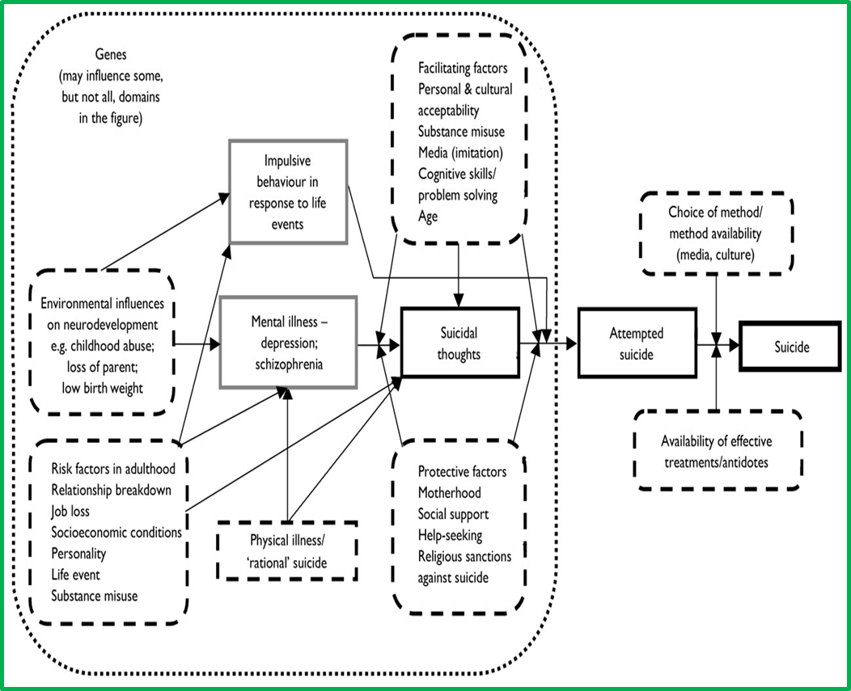

Some groups of people are known to be at higher risk of suicide than the general population. Groups at high risk of suicide¹ are:
- Men aged 35-54 years
- People in the care of mental health services, including inpatients
- People with a history of self-harm, untreated depression, misuse of alcohol, those who are facing economic difficulties, are going through divorce or separation, or have long-term physical illnesses
- People in contact with the criminal justice system (police, probation, the courts and prisons)
- Specific occupational groups, such as doctors, nurses, veterinary workers, farmers and agricultural workers
- Young women from South Asian, Caribbean and African origin and older South Asian women,
- Children and young people who have experienced abuse and/or neglect
- Lesbian, gay, bisexual or transgender people
- Older people aged 65+ experiencing social isolation and loneliness.

Table 1 below shows the estimated increased risk for the high risk of suicide groups compared with that of the general population. The highest risk of suicide group are patients up to 4 weeks following discharge from a psychiatric hospital with an estimated increased risk of 100-200 times.

Table 1: Increased risk for groups at higher risk compared to the general population. Source: Adapted from information on Mental Health Specialist Library website at www.library.nhs.uk/mentalhealth
High risk group | Estimated increased risk
Males compared to females | x 2-3
Current or ex-psychiatric patients | x 10
4 weeks following discharge from inpatient psychiatric hospital | x 100-200
First year after self-harm | x 60-100
Alcohol misuse and dependency | x 5-20
Drug misusers | x 10-20
Family history of suicide | x 3-4
Serious physical illness/disability | Not known/under review
Prisoners | x 9-10
Offenders serving non-custodial sentences | x 8-13
Doctors | x 2
Farmers | x 2
Unemployed people | x 2-3
Divorced people | x 2-5
People on low incomes (social class IV/V) | x 4

6.2 Other factors associated with suicide and self-harm

Suicide and self-harm is often precipitated by recent adverse events across the life course. These include relationship breakdowns, conflicts, legal problems, financial concerns, interpersonal losses, traumatic events. There is also research into the links between suicide and terminal and/or chronic illness.
The following points are also important in terms of suicide prevention:⁴²
- In up to half of all suicides there have previously been failed attempts
- Only a quarter of people (nationally) who die by suicide are under psychiatric care in the year before their death (i.e. 75% are not)
- 5-10% of all suicides happen in the four weeks after discharge from psychiatric hospital, making this a time of high risk
- Following a suicide attempt or completion, adolescents are at an increased risk of copycat suicides. Reports indicates that youth suicide can increase two to four times more following exposure to another individual’s suicide than among older age groups
- Repeated exposure to bullying and cyber-bullying may precipitate or aggravate depression, anxiety, psychosomatic symptoms, eating difficulties and self-harm, and is associated with suicide. Exposure to bullying is also associated with elevated rates of anxiety, depression and self-harm in adulthood
- A number of occupational groups - doctors, farmers, vets, dentists and pharmacists - are at increased risk of suicide, although deaths in these groups make up only 1-2% of all suicides. One important factor influencing the increased risk in these occupations is their access to lethal means of suicide.¹
- The risk of suicide in men aged 24 years and younger who have left the Armed Forces is approximately two to three times higher than the risk for the same age groups in the general and serving population.
- Victims of sexual or domestic violence in adulthood is associated with the onset and persistence of depression, anxiety and eating disorders, substance misuse, psychotic disorders and suicide attempts.
- Several physical disorders such as diabetes, epilepsy and asthma are associated with increased risk of self-harm and suicide.
- The risk of suicide is four times more likely in gay and bisexual men and higher rates of suicidal thoughts and self-harm in lesbian and bisexual women compared to women in general.
- Suicide in older people is strongly associated with depression.
- A follow-up study of patients at a general hospital, reported a 0.7% risk of adults dying by suicide in the year following self-harm, a 1.7% risk within five years and 2.4% at ten years. The risk was far higher in men than in women.
- More men die from suicide than women, but suicidal thoughts and self-harm are more common in women.
Groups who have more frequent thoughts of suicide are:
- Women
- Those aged 16 to 24
- Those not in a stable relationship
- Those with low levels of social support
- Those who are unemployed.

6.3 Mental health services and suicide

The most recent National Confidential Inquiry into Suicide and Homicide by People with Mental Illness report (2017)⁴³ has shown that mental health patient suicides have fallen in recent years in England, with a downward trend in the number of suicides by patients recently discharged from hospital, and in those who were non-adherent with drug treatment in the month before death: both highlighted as significant groups of concern. While inpatient suicides have likewise fallen, the trend has slowed. These trends are despite an overall increase in the number of people under mental health care.
The report also noted that the commonest method of suicide by patients in the UK is hanging, with the next most common method being self-poisoning. Opiates and opiate-containing compounds remain the main type of drug taken in fatal overdose, including both prescribed and illicit drugs.

6.4 Offenders and suicide

People at all stages within the Criminal Justice System, including people on remand and recently discharged from custody, are at higher risk of suicide. The period of greatest risk is the first week of imprisonment.⁴⁴ Reasons for this increased risk include the fact that a high proportion of offenders are young men, who are already a high suicide risk group, although the increase in suicide risk for women prisoners is greater than for men. An estimated 90% of all prisoners have a diagnosable mental health problem (including personality disorder) and/or substance misuse problem¹.
The patterns for both rates and numbers of self-inflicted deaths in custody closely mirror each other. Prison suicides are no longer falling after a major fall in 2004-08, with about 60 deaths each year, nationally, representing a rate of 0.7 per 1,000 individuals in custody. Suicides in women prisoners are rare⁴³.

6.5 Risk factors specific to self-harm

Self-harm occurs in all sections of the population but is more common among people who are disadvantaged in socio-economic terms and among those who are single or divorced, live alone, are single parents or have a severe lack of social support.⁴⁵ According to NICE, risk factors for self-harm include a number of other ‘associations’ such as: life events; alcohol and drug use; mental disorder; child abuse, domestic violence and being within the criminal justice system. Within this are special groups such as young people. There are others for whom the evidence is not so well collected such as gay men, lesbians and bi-sexual people.¹⁸

6.6 Rates of self-harm

The Department of Health estimates that self-harm represents one of the top five reasons for admissions in Accident and Emergency services.⁴⁶ There are around 200,000 episodes of self-harm that present to hospital services each year,⁴⁷ although many people who self-harm do not seek help from health or other services, and so are not captured by this.
People who self-harm are at increased risk of suicide, although many people do not intend to take their own life when they self-harm.⁴⁸ At least half of people who take their own life have a history of self-harm, and one in four have been treated in hospital for self-harm in the preceding year. Suicide risk is particularly increased in those repeating self-harm and in those who have used violent/dangerous methods to self-harm.⁴⁹
The rates of self-harm are highest in girls and women with the highest incidence being among 15-19 year olds. There has been a recent rise in self-harm presentations to paediatric departments, particularly among girls, which in some areas exceeds 50%.⁵⁰ In men, the highest rates are in 20-29 year olds.⁵¹ In a previous study of over 4000 self-harming adults in hospital, 80% had overdosed and around 15% had cut themselves. NICE suggests that in the community, it is likely that cutting is a more common way of self-harming than taking an overdose.²⁶ As the majority of young people who self-harm do not present to statutory services, available self-harm data is a likely underestimation of the true incidence of self-harm. Self-harm is often carried out in secret and so will often not come to medical attention.
The Multicentre Study of Self-harm in England studied 1,177 older adults aged 60 years and over who had presented to hospital with self-harm and found that within one-year of their self-harm presentation, 1.5% of older adults had subsequently died by suicide. Their risk of suicide was 67 times greater than older adults in the general population. Men aged 75 years and over had the highest suicide rate. Also examined were older adults who re-presented to hospital with another non-fatal self-harm episode: 12.8% repeated self-harm within one-year. Risk factors for non-fatal repetition included previous self-harm, previous psychiatric treatment and age 60–74 years.⁵²

6.7 Protective factors

There are a number of factors which research suggests protect some people against suicide.^{53–55} These include:
- Stable and supportive family and social networks
- Being open about feelings and able to talk about concerns
- A sense of hope for the future
- Ability to problem-solve and set goals

7.0 Suicide rates and trends

The data cited in this strategy is taken from that most recently published by official bodies, most notably the Office of National Statistics (ONS), on suicide data. This has been analysed according to the calendar year in which the death was registered (as opposed to when it occurred), which follows the coroner’s inquest verdict. Analysis is also based on the postcode of usual residence of the deceased (rather than where the death occurred). Suicide rates have been standardised for age and sex unless otherwise stated. This allows for comparisons over time and between localities, which may differ in the size and age structure of their populations.
In the UK, a coroner is able to give a conclusion of suicide for those as young as 10 years. However, rates per 100,000 are provided by the ONS only for ages 15 years and over when the suicide bulletin is released. This is due to a number of factors, including the known subjectivity between coroners^{56,57} with regards to classifying children’s deaths as suicide, and the small numbers involved in under-15 suicides leading to variable and potentially misleading rates.

7.1 National data

The fourth progress report by HM Government on Preventing Suicide in England²⁰ outlines that:
- There has been an encouraging reduction in suicide rates amongst men over the past four years, with the suicide rate now at its second lowest recorded level, from 16.0 in 2014 to 14.0 in 2017.

- Despite this, men remain the group at highest risk, and suicide data monitoring suggest there may be increases in these groups after 2017. Males continue to account for around three quarters of all suicides (3,328 out of 4,451 suicides were males in 2017) and suicide is the biggest killer of men under 50 and a leading cause of death in young men.

- The rate of suicide in those who are in contact with mental health services continues to reduce, although such people still account for around a third of all suicides in England, and are some of the most preventable suicides.

- Around 25 per cent of mental health patients who die by suicide have a major physical illness (accounting for 3,410 deaths between 2005 and 2013).

- About a third of people who take their own life will have seen their GP recently before their death.

- Presentations for self-harm by young girls aged 13-16 at GP practices have increased by 68 per cent from 45.9 per 10,000 in 2011 to 77.0 per 10,000 in 2014.

7.1.1 National and regional trends

Because annual rates for suicide can fluctuate widely from year to year, a three year rolling average is conventionally used to provide a more accurate representation of trends.
Figure 2 below, illustrates suicide and injury undetermined death rates from 1995 to 2017. It can be seen that nationally and locally, these rates are showing a gradual overall downward trend.
There are fluctuations in rates which are more extreme for smaller (i.e. local) areas, demonstrating the effect of noise (random variation) which is more pronounced with smaller numbers. Although the latest data (2017) shows both Nottingham and Nottinghamshire to be above regional and national rates, it is difficult to draw any inference from this alone, given such marked fluctuations.
Figure 2: Trends in mortality from suicide and injury of undetermined intent in 15+yrs old (directly standardised rate per 100 000). Source: Office for National Statistics (ONS) via NHS Digital
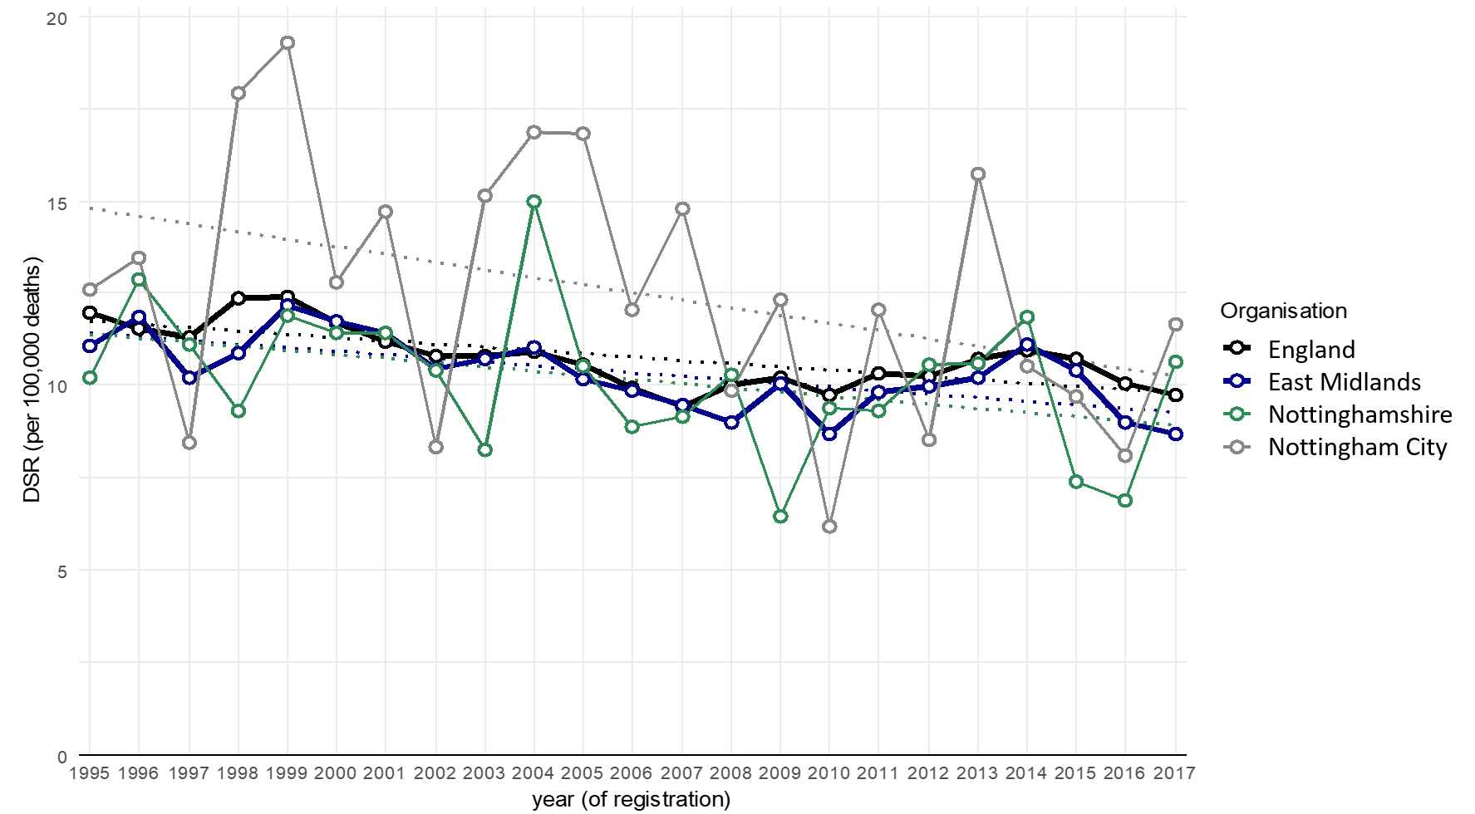

7.1.2 Suicide rate by age and gender

Figure 3 shows the most recent suicide and injury undetermined death rates by age groups. It can be seen that local rates broadly mirror regional and national ones, and that the 35-64 age bracket remains the highest across all areas. The true number of suicides amongst young people may be understated, as it can be much more difficult to reach a conclusion of suicide beyond reasonable doubt.

Figure 3: Variation in Mortality from suicide and injury undetermined death (3 year pooled, 2015-17) by age. Source: NHS Digital
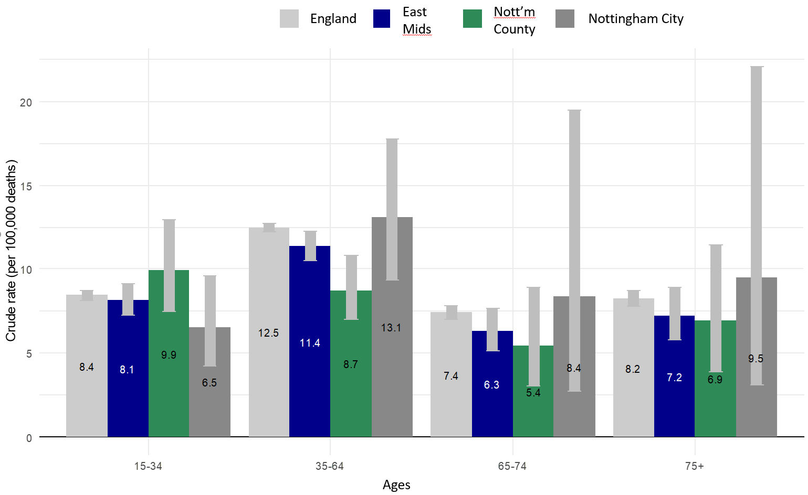

7.2 Local data

This section summarises the local rates and trends in the incidence of suicide and undetermined intent death rate as well as particular risk factors in Nottingham City and Nottinghamshire. Some comparisons against the national trends are given.

7.2.1 Suicide rate and deprivation

The Index of Multiple Deprivation score 2010 (IMD 2010) is a measure of multiple deprivation, at small area level. It is made up of seven domain indices, relating to income deprivation, employment deprivation, health deprivation and disability, education, skills and training deprivation, barriers to housing and services, living environment deprivation, and crime. A higher IMD number indicates a higher level of deprivation for that area.

Research suggests that there is a strong relationship between suicide and socio-economic deprivation. Figure 4 below shows the relationship between deprivation and suicide rate for Nottingham City and all Nottinghamshire districts.

Over half of the population of Nottingham live in the 20% most deprived areas in the country and many risk factors for poor mental health are significantly higher in the city, such as unemployment, levels of violent crime and numbers of children in care.

Figure 4 shows variations in mortality from suicide and injury of undetermined intent for Nottingham City and County districts, plotted against deprivation scores for each area. Although there is a wide degree of uncertainty (represented by the confidence interval bars) due to the small numbers involved, a potential trend can be seen with increasing rates as deprivation increases. As shown, Bassetlaw district has the highest suicide and injury-undetermined-death mortality burden of the districts, although again, the wide confidence intervals should be noted.

Figure 4: City and County districts variation in mortality from suicide and injury undetermined death (3 year pooled, 2015-17) with deprivation. Source: PHE suicide prevention profiles; IMD 2015 scores
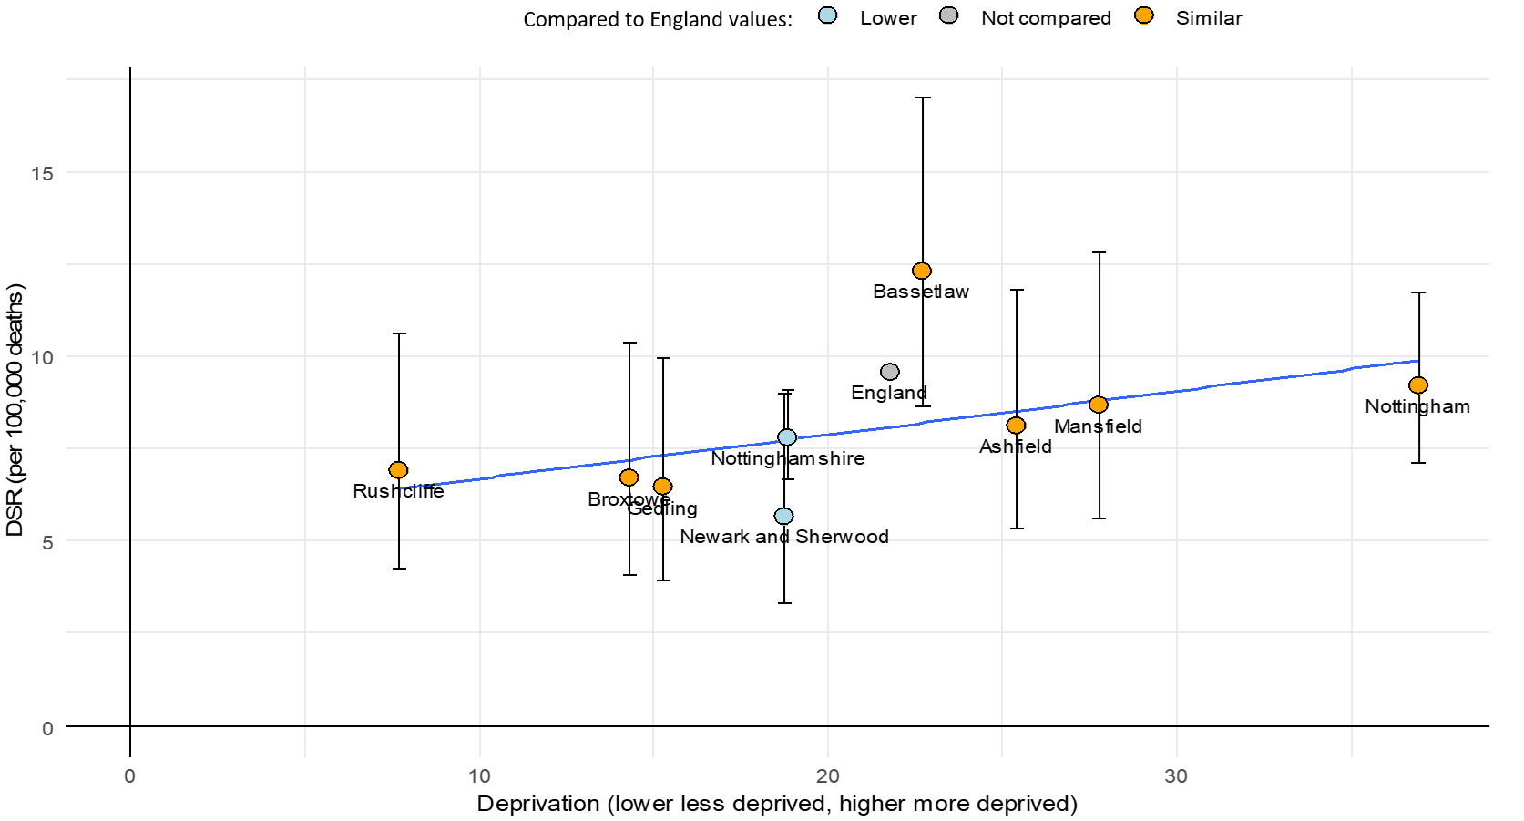

7.2.2 Suicide rate and gender

Figure 5 demonstrates the gender breakdown in deaths from suicide and injury undetermined death. This is a longstanding trend with no notable difference in recent data; national suicide rates consistently place men at around three quarters of suicides.

Figure 5: Percent of deaths from suicide and injury undetermined death (2008-2017) by sex within local areas. Source: ONS mortality extracts
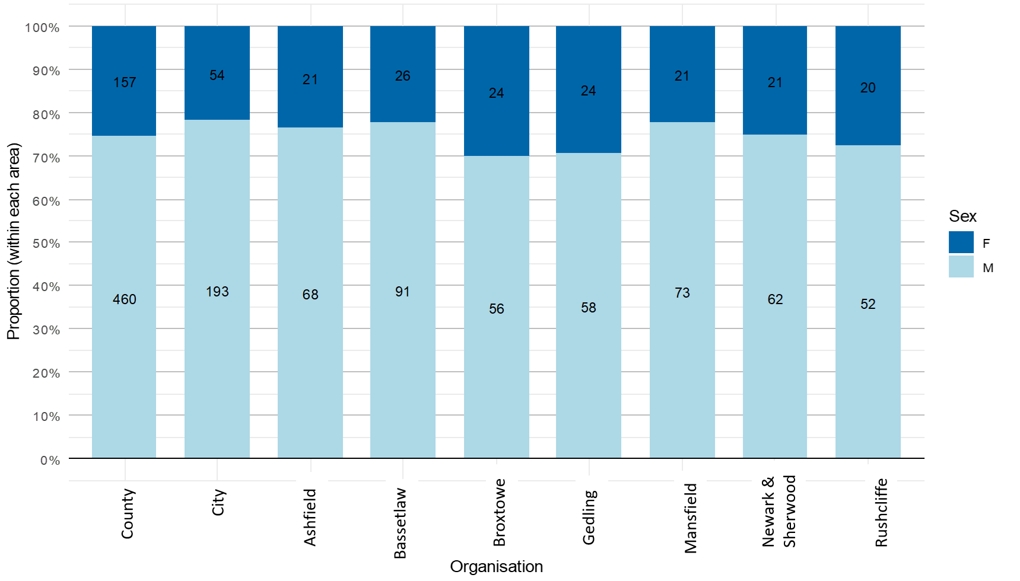

7.2.3 Methods of suicide and self-harm

Figure 6 shows a breakdown by sex and method, for both non-fatal self-harm and deaths (by suicide or injury undetermined). The combined figures for Nottingham City and Nottinghamshire County are shown. Hanging, suffocation and strangulation are by some margin the most common methods across both genders and in both self-harm and suicide. Hanging, suffocation and strangulation are more likely in males than females. Poisoning is more likely in females than males.
When older people self-harm, it should be noted that the risk of further self-harm and suicides are substantially higher. All acts of self-harm in people older than 65 years of age should be regarded as evidence of suicidal intent until proven otherwise, as the number of people in this age range who go on to complete suicide is much higher than in younger adults.⁵⁸

Figure 6: Deaths from suicide and injury undetermined death (2008-2017) by method and sex, across Nottingham City and Nottinghamshire County combined. Source: ONS mortality extracts
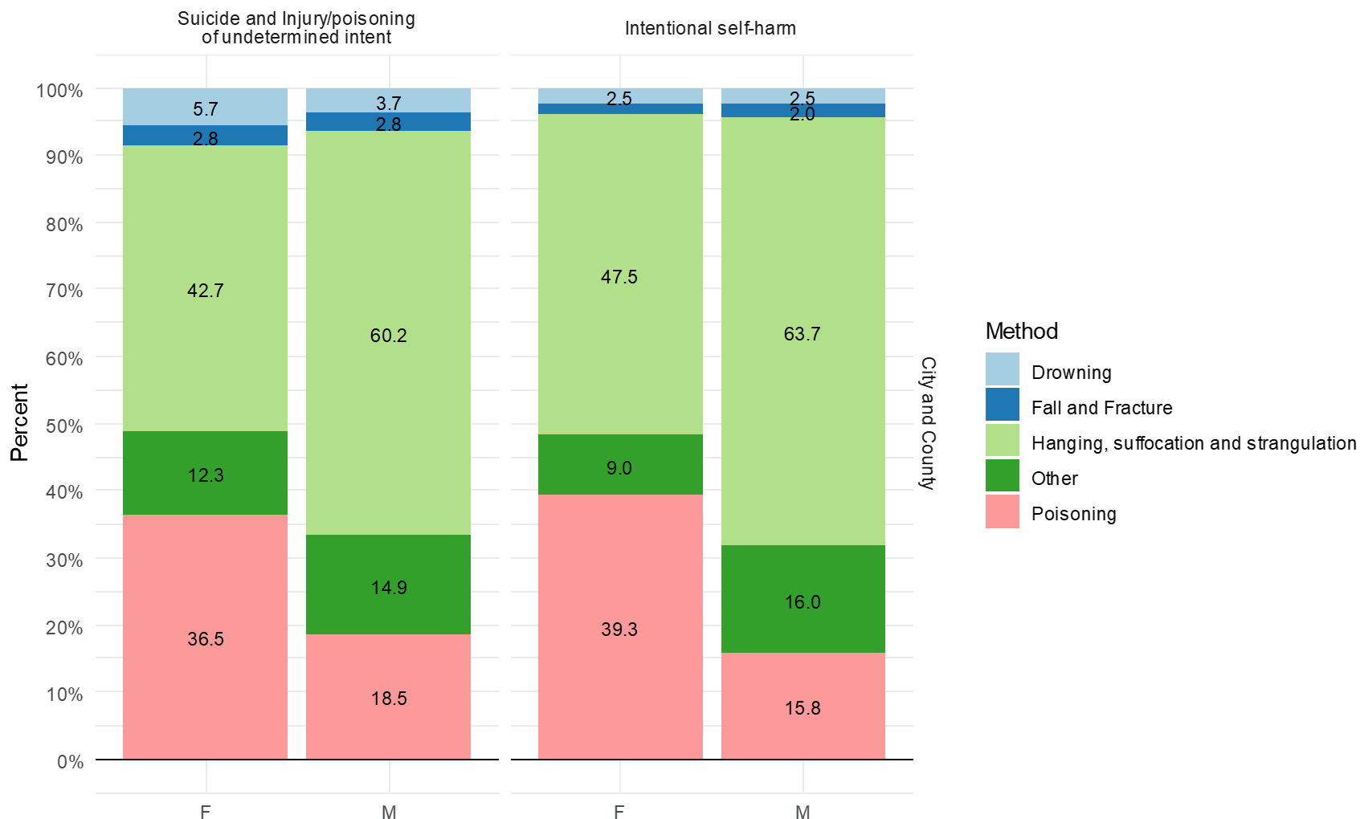

7.2.4 Ethnicity

The 2011 census data indicates Nottingham City’s population is 65.4% White British and 34.9% Black and Minority Ethnic (BME). Nottinghamshire’s population at the time of the 2011 Census was 92.6% White British and 4.5% BME. Census averages for England were 85.4% White British and 15.2% BME.
Local level ethnicity data with regard to cases of suicide is not currently available through existing information sources. The relatively recent approach of using police-reported data via real-time surveillance holds promise for providing a clearer picture of ethnicity breakdown. As this approach develops, more detailed local analysis may well become possible.
The available national evidence highlights the existence of an increased risk to those from ethnic minority communities:
- Patterns of self-harm and suicide amongst people from minority ethnic groups continue to be different to those amongst white people. It has been reported that the highest rate of suicide in the BME groups is in young black females age 16-34 years.¹³
- Suicide rates and classical indicators of suicide risk among inpatients committing suicide vary by ethnic group. Black African men have the highest rates of suicide compared to the White British group.¹³

8.0 Progress since the previous strategy

In order to set appropriate strategic priorities and actions, it is helpful to know where progress has been made, and what the local situation is in relation to suicide and self-harm prevention. This was approached in two ways. The existing strategy was evaluated using a World Health Organisation mental health strategy evaluation tool,⁵⁹ to analyse its impact and progress against its vision. Key stakeholders of the Nottinghamshire and Nottingham City suicide prevention steering group were then consulted via a workshop exercise, using the evaluation results to help inform an exploration of areas to concentrate on within the new strategy. This has enabled the identification of new strategic priority areas.
Points of particular note in the evaluation were:
- No significant differences were found between City and County strategies.
- Appropriate collaborative working was evident in creating and implementing the strategies.
- Clear vision, values and principles were present, backed up by appropriate evidence and data.
- There was recognition of the importance of promoting good mental health in the general population, and promoting greater awareness in staff.
- There was a paucity of acknowledgement of wider principles such as human rights, social inclusion, equity with physical healthcare, and institutionalisation.
- Passive language was used throughout.
- There was an overabundance of actions, with sometimes vague or imprecise linking with some organisations and sectors.
- Some risk groups were not acknowledged, particularly severe mental illness and intellectual disabilities, although these were small in absolute terms.

Some of these points suggest areas to improve on with the refreshed strategy. These have been acted on where feasible. Certain points were not feasible to act upon, however. A wide range of risk groups exist in the research literature, and given pragmatic constraints, it is sensible to select those of greatest pertinence to the local area, and those where action is likely to have the greatest positive impact, rather than attempting to concentrate on every risk group.

9.0 Strategy aims and priorities

Suicide prevention is not the sole responsibility of any one sector of society, or of health services alone. Therefore, prevention largely necessitates a general population approach rather than service-related initiatives. For example, restriction of access to means for suicide, population approaches to prevention of depression, improved detection and management of psychiatric disorders in primary care, and voluntary agency and internet-based support.⁶⁰
As well as targeting high-risk groups, another way to reduce suicide and self-harm is to improve the mental health of the population as a whole. A life course approach recognises that mental health problems often start in childhood, and that opportunities to promote and protect good mental health arise form pre conception through to old age. The greatest impact in suicide prevention is thus likely to result from a combination of preventative approaches directed at potential suicide determinants across the life course, which include both:
- Factors which increase the risk of suicidal behaviour in a population; for example, availability of means, knowledge and attitudes concerning the prevalence, nature and treatability of mental disorders, and media portrayal of suicidal behaviour
- Recognised high risk groups - e.g. people with recurrent depressive disorders, previous suicide attempts, people who misuse alcohol, the unemployed, people with certain co-morbid mental and personality disorders and people recently discharged from psychiatric inpatient care.
Since the 2002 National Suicide Prevention Strategy, emphasis has shifted from focusing on achieving suicide prevention through a reduction in suicide target, to that of viewing this target as
'…. a guiding beacon that can lead to the problem of suicidal behaviour being taken more seriously and galvanise more active planning of national policy to improve mental health and mental health care.’
This suicide prevention strategy aims to reduce the suicide and self-harm rate in Nottingham City and Nottinghamshire. The strategy has been developed in line with national policy, including the Suicide Prevention Strategy for England and its updates. It also builds on the previous local suicide prevention strategy and existing local work.

9.1 Overall aim

The overall aim of this strategy is to reduce the rate of suicide and self-harm in the Nottingham City and Nottinghamshire population, by proactively improving the population mental health and wellbeing, and by responding to known risks for suicide in the population.
This strategic ambition is consistent with the national suicide prevention strategy for England.
Although self-harm and suicide are distinct entities, the strong and close relationship between them means that both have been included in this strategy’s overall aim.

9.2 Strategic priorities

Strategic suicide prevention priorities
Priority 1: At-risk groups
Identify early those in groups at risk of suicide, and ensure they have access to evidence-based interventions. Pay particular attention to:
- Men
- Men in contact with/in transition through the criminal justice system
- Students
- Children and young people
- Self-harm as a risk factor

Priority 2: Use of data
Collect and review suicide and self-harm data in a timely manner, using it to inform local practice. Particularly via:
- Real-time surveillance

Priority 3: Training and bereavement support
Ensure the availability of prompt bereavement support for those affected by suicide.

Priority 4: Staff training
Provide effective training for frontline staff to recognise and respond to suicide risks.

Priority 5: Media
Foster close engagement with media personnel to ensure that suicide and suicidal behaviour are reported with sensible, sensitive approaches.

9.2.1 Priority 1: At-risk groups

This priority outlines the known risk factors for suicide. This does two things: it reveals “at-risk” groups in the population, for whom interventions can be targeted; it also shows that primary preventative measures aimed at the whole population can be effective, when they address the root causes of these risks.
Successfully meeting this priority therefore calls for a two-pronged approach that can address suicide prevention at both levels.

9.2.2 Priority 2: Use of data

To achieve this priority we need to improve timely data capture. This will enable suicide prevention and interventions strategies to target the most at risk groups, as well as to identify and respond rapidly to emerging patterns. Using data to inform local approaches, and to enable evidence based research and practice, is also a key part of this priority, and will ensure effectiveness at reducing the rate of suicide and self-harm.

9.2.3 Priority 3: Training and bereavement support

Suicide can have a profound effect on the local community. We know from studies that, in addition to immediate family and friends, many others will be affected in some way. They can include carers, neighbours, school friends and work colleagues, but also people whose work brings them into contact with suicide – emergency and rescue workers, other healthcare professionals, teachers, the police, faith leaders and witnesses to the incident. It is important to ensure appropriate and timely bereavement support is available for all those so affected.

9.2.4 Priority 4: Staff training

This priority area focuses on the adequate training of staff. Equipping staff to be more aware, to identify early those at risk of suicide, and how to most effectively intervene, is important in supporting people and services.

9.2.5 Priority 5: Media

The media have significant influence on behaviour and attitudes. There is evidence to suggest that the reporting of suicide in the media can increase the rate of suicide, particularly amongst young people who may already be at risk. It is clear that the media have a role to play in suicide prevention, by limiting certain aspects of reporting, providing details of local support organisations and helplines and by portraying suicide in ways which may discourage imitation.

9.3 Monitoring Outcomes

The overall aim of this strategy is to reduce the rate of suicide and self-harm in the Nottingham and Nottinghamshire population, by proactively improving the population mental health and wellbeing, and by responding to known risks for suicide in the population.
Measuring the success of this is complex due to the levels, types and complexities of suicide and its associated risks. Data has its limitations, as mental health problems can go under diagnosed or under reported, and there is often a lack of timely data available.
In order to monitor this strategy’s progress and outcomes we will be looking at a number of key national indicators:
- The national outcome framework: the Public Health Outcomes Framework, with specific indicators to monitor a range of mental health and suicide-related outcomes
- The Department of Health (DH), No Health without Mental Health dashboard brings together a number of indicators for a wide range of sources to reflect progress against the national mental health strategy.
- Locally, specific process and distal indicators will be developed in accordance with the strategy’s Action Plan to facilitate monitoring and subsequent evaluation.

10.0 Taking the Suicide Prevention Strategy forwards

10.1 Leadership and governance

To realise the aims of the Nottingham City and Nottinghamshire County Suicide Prevention Strategy, and in order to see real improvement in the City and County population, we need suicide prevention leaders and champions at all levels across the public and voluntary sectors.
Those of particular note are:
- Councillors and officers of Nottingham City Council and Nottinghamshire County Council.
- Senior leaders, including commissioners and mental health clinical leads.
- Service providers, including NHS Trusts and the third sector.
The Health and Wellbeing Boards at both Nottingham City and Nottinghamshire County will have oversight of the suicide prevention strategy, as will the Nottinghamshire ICS, via the ICS Mental Health and Social Care Board. It will be steered by the Nottinghamshire and Nottingham City Suicide Prevention Steering Group, comprising key stakeholders who will continue to deliver against this strategy’s key actions. The overarching leadership for each priority area will be developed, and will consist of the most appropriate suicide prevention leaders and champions.

10.2 Suicide Prevention Strategy action plan

An action plan has been developed as part of stakeholder consultation on the strategy, based on the five key priority areas outlined above.

Suicide Prevention Action Plan
Rate | Target
ICS Nottingham and Nottinghamshire - All persons suicide age-standardised rate per 100,000 population (3 year average) 2015-17. | NHS - The Five Year Forward View for Mental Health (Feb 2016) – Target reduce suicide by 10 per cent by 2020/21.
Suicide: age-standardised rate per 100,000 population (3 year average) (all persons) is 9.6 per 100,000 population or 202 suicide deaths or roughly 68 per annum (2015-2017).
Nottingham City - All persons suicide age-standardised rate per 100,000 population (3 year average) 2015-17.
Suicide: age-standardised rate per 100,000 population (3 year average) (all persons) is 9.2 per 100,000 population or 71 suicide deaths or roughly 23 per annum (2015-2017).
Nottinghamshire County - All persons suicide age-standardised rate per 100,000 population (3 year average) 2015-17.
Suicide: age-standardised rate per 100,000 population (3 year average) (all persons) is 7.8 per 100,000 population or 168 suicide deaths or 56 per annum (2015-2017).
Emergency Hospital Admissions for Intentional Self-harm: Directly age-sex standardised rate per 100,000 2014-2015 and 2016-17
2017/18 Nottingham City rate 229.5 per 100,000 population/or 850 admissions
2014/15 Nottinghamshire County rate 196.7 per 100,000 population/or 1,538 admissions

At risk group/s | Rationale | Actions | Stakeholder | Milestones/Outcomes | RAG | Date review/updated
- All ages Population Approaches | Universal Suicide Prevention approaches | 1.1.Promote ‘Safe to Talk’ about Suicide | All | - Currently, advertised on Notts Help Yourself and appearing at the top of the topic search  - Ensure equivalence with Nottingham City Ask LiON
 |  |  |  | - Engage with all health champions, Mental Health Champions, Mental Health First Aiders, Council’s Customer service staff to promote Safe to Talk leaflets
 |  |  | University | - Nottinghamshire University to promote and embed ‘Safe to Talk’ about Suicide alongside suicide awareness training
 |  |  | Police | - Liaise with PCC to explore opportunities to increase Suicide Prevention awareness for Sexual Abuse Victims
 |  |  | Police | - Nottinghamshire Police signpost leaflets to the Street Triage Service and Liaison and Diversion service  - Advertise in Police staff and locker rooms
 |  | 1.2 Promote ‘Safe to Talk about Self-harm | All | - Following publication advertise leaflet on Notts Help Yourself to appear at the top of the topic search
 |  | 1.3. Promote app ‘Stay Alive’ | All | - Promote ‘Stay Alive’ on Notts Help Yourself
 |  |  | NHCT | Review application of app for use on Mental Health wards inpatient safety plans
 | WHO Suicide Prevention Day | 1.4. Promote support on self-harm behaviour and interventions for middle aged men with suicidal thoughts | City/County Public Health | - Develop and implement an agree joint (City/County)approach for World Suicide Prevention Day
 |  |  | City CCG | - Promote ‘Safe to Talk’ leaflets in high male population workplaces, business and environments
 |  | 1.5 Raise awareness in places where men access – pubs and sport/ leisure facilities | All | - As above – promote as part of World Health Suicide Prevention Day  - Nottinghamshire Police promoting
- CYP Population Approaches | Promote good mental health in CYP to prevent mental health problems that could lead to suicide and self-harm thoughts and ideation | - Mental Health support teams in schools trailblazer on Self Harm prevention | City/County Public Health, CYP Commissioners
 |  | 2.2 Academic resilience in schools |  | – Review the feasibility of extending academic resilience across the City and County
- All age – at risk settings | Network Rail Suicide deaths – Nottinghamshire is an escalation site | 3.1 Linked to RTS regular updates on lessons learnt | BTP, Network Rail, Public Health, NHCT | - Public Health analyst receiving daily Rail Deaths Network Rail reports  - Network Rail and BTP have an alert system is in place when rail ‘hotspots’ are identified
 | Aspiration for NHCT to adopt the Zero Suicide | 3.2. NHCT implement Towards Zero Suicide Strategy | NHCT | - Launch of Toward Zero Suicide September 2019
 |  |  |  | - Yr 1 priorities – improve access to inpatient Suicide Prevention training
 |  |  |  | - Develop and implement an Offender Health Suicide Prevention Pilot Project
- Men in contact with the criminal justice system | Men in contact with criminal justice system are at high risk of suicide at transitional points (in or out of prison or police custody) | 4.1.Qualitative Evaluation to review effectiveness of the Pilot Welfare Assessment in early detection of those at risk of self-harm and suicide targeting men charged with sexual offences | University | - Share Pilot finding with Suicide Prevention Steering Group to consider if feasible ways to implement across the Criminal Justice system
 |  |  | Police | - Link with PCC and Ministry of Justice to implement across offender work
 |  | 4.2 Linked to RTS regular updates on lessons learnt | City/County Public Health | - Share with Suicide Prevention Steering Group lessons learnt
- University and Further Education College Students | CYP at increased risk of suicidal thoughts and self-harm a life pressure points i.e. exams, transition from school to university and college etc. | 5.1 Implement Safe Suicide response | University | - University of Nottingham Suicide Prevention Task and Finish group developing a Safe Suicide response
 |  |  |  | Universities to report outcomes to Suicide Prevention Steering Group on the effectiveness Safe Suicide response
 |  | 5.2. Ensure access to bereavement pathway | Police | - Explore the opportunity to consider bereavement support within the CYP commissioned victims services
 |  | 5.4 Offer support to universities on the wider offer and availability of Suicide Prevention awareness and interventions | University | - University of Nottingham have developed a Draft Suicide Prevention Plan to be circulated to the Suicide Prevention Steering Group
 |  |  | City/County Public Health | - Engage with Nottingham Trent University regarding if any support can be offered in the development of their Suicide Prevention Plan
- Quality review | Real Time Surveillance in order to review means hotspots, clusters and methods to ensure targeted prevention is reaching those most at risk | 6.1.Replicate the NUH ED Self-harm audit in Sherwood Hospital and Bassetlaw Hospital | City/County Public Health | - Review the feasibility for replicating the ED Self Harm audit in SHT and Bassetlaw Hospital
 |  | 6.2. Agree criteria to identifying near suicide misses | RTS working group | - RTS working group review the WHO on criteria for identifying and reporting mechanisms serious near misses
 |  | 6.3. Suicide Prevention Steering group to oversee the RTS working group plans | City/County Public Health | - RTS working group to report on timely suicide data and consider lessons learnt
 |  | 6.4. Suicide Prevention to target any at risk groups identified through RTS | All | - Quarterly report to Suicide Prevention Steering Group on Suspected Suicide Deaths and report on identified hotspots
- Bereavement support | Ensure those who are affected by a person’s suicide have access to timely interventions | 7.1 NHS England funding to be greed for bereavement support | City/County Public Health | - Implement and review for effective outcomes the bereavement support pathway
 |  | 7.2 Ensure CYP have access to suicide bereavement support | City/County Public Health | - NHSE bereavement support proposal includes all ages  - Bassetlaw CCG commission a bereavement service for CYP
- Media | A skilled workforce in suicide and self-harm early identification and intervention | - Awaiting learning from the ICS SYB Media workshop and review what could be implemented locally | City/County Public Health | - Liaise with local media to explore perceptions and uptake of national guidance around suicide reporting, including Samaritans Sensible Media Reporting
 |  | - Develop a co-ordinated plan to respond to the media in cases of suicide irresponsible reporting | City/County Public Health | - Implement the Samaritans Sensible Media Reporting Guidelines
- Training | A skilled workforce in suicide and self-harm early identification and intervention | - Mapping of Suicide Prevention training across the organisation | ICS Workforce work stream | - Need to ensure Suicide and Self-harm training needs are considered in the ICS workforce development plans
 |  | - SP steering group member to link into ICS Mental Health training work stream to ensure suicide and self- harm training is addressed | All | - Promote best evidence training  - HEE 60 minutes on line training We need to talk about suicide  - Zero Suicide Alliance 20 minute training- https://www.zerosuicidealliance.com/training  - HEE SP competency framework https://www.ucl.ac.uk/pals/self-harm-and-suicide-prevention-competence-framework  - Learning from wave 1 sites inc campaigns etc www.rcpsych.ac.uk/improving-care/nccmh/national-suicide-prevention-programme
 |  | 9.3 PMHT – Self-harm, suicide prevention and bereavement training for teachers | City/County Public Health, CYP Commissioners
 |  | 9.4 Increase Knowledge and Skills on Suicide Prevention for Nottinghamshire Police | Police | - Suicide Prevention training is being offered to Nottinghamshire Police via e-learning

 | Completed – work has been successfully completed to deadline |  | On schedule – work has started and is meeting milestones
 | Happening but behind schedule – work has started, activity is not meeting milestones, but is expected to by the deadline if adjustments are made |  | Behind or not happening – work has not started when scheduled or has started but activity is not meeting or unlikely to meet its milestones
 | No information received

10.3 Equality Impact Assessment

An equality impact assessment (EIA) is an assessment to ensure that policies do not discriminate, and that where possible, equality is promoted. A full equality impact assessment of this strategy will be undertaken in accordance with the relevant local authority Equality and Diversity Policies.

11.0 Appendices

Appendix A: Local Policy Drivers

Key local documents

- Happier Healthier Lives, the Nottingham City Joint Health and Wellbeing Strategy 2016-2020

- Nottinghamshire County Council Joint Health and Wellbeing Strategy 2018 - 2022

- Nottingham City Suicide Prevention Strategy 2014-2017

- Nottinghamshire Suicide Prevention Framework for Action 2014-2017

- Nottingham City Joint Strategic Needs Assessment (JSNA) 2018

- Nottinghamshire Joint Strategic Needs Assessment (JSNA) 2016

- The Nottingham Plan 2020

- Everyone’s different, everyone’s equal: All-age integrated mental health and social care strategy, Nottingham and Nottinghamshire Integrated Care System, 2019

- The Nottingham City Joint Carers Strategy 2012 to 2020

12.0 REFERENCES

1. HM Government and Department of Health. Preventing suicide in England: A cross-government outcomes strategy to save lives. Evidence Brief. 2012.
2. HM Government. Government Response to the Health Select Committee’s Inquiry into Suicide Prevention. 2017;
3. Samaritans. Dying from inequality. 2017; Available from: http://www.samaritans.org/sites/default/files/kcfinder/files/Samaritans Dying from inequality report - summary.pdf
4. HM Government. No health without mental health. 2011.
5. Department of Health and Social Care. The NHS long term plan. 2019.
6. Mental Health Foundation. Mental Health Statistics: Suicide [Internet]. 2018 [cited 2019 Jan 2]. Available from: https://www.mentalhealth.org.uk/statistics/mental-health-statistics-suicide
7. Survivors of Bereavement by Suicide. How suicide affects others – Survivors of Bereavement by Suicide [Internet]. [cited 2019 Jan 9]. Available from: https://uksobs.org/about/suicide-bereavement/how-suicide-can-affect-you/how-suicide-affects-others/
8. Cerel J, Jordan JR, Duberstein PR. The impact of suicide on the family. Crisis. 2008.
9. STENGEL E. The social effects of attempted suicide. Can Med Assoc J [Internet]. 1956 Jan 15;74(2):116–20. Available from: https://www.ncbi.nlm.nih.gov/pubmed/13284662
10. Kinchin I, Doran CM. The Economic Cost of Suicide and Non-Fatal Suicide Behavior in the Australian Workforce and the Potential Impact of a Workplace Suicide Prevention Strategy. Int J Environ Res Public Health [Internet]. 2017 Mar 27;14(4):347. Available from: https://www.ncbi.nlm.nih.gov/pubmed/28346379
11. NICE. Suicide prevention NICE quality standard - Draft for consultation. 2019;
12. Royal College of Psychiatrists. Self-harm, suicide and risk: a summary. 2010;
13. Royal College of Psychiatrists. Self-harm, suicide and risk : helping people who self-harm. College Report CR158. 2010.
14. Kučukalić S, Kučukalić A. Stigma and Suicide. In: Psychiatria Danubina. 2017.
15. Eves G, Berryman A, Reading C, Reedy L, Mcadam M, Shanley J, et al. Nottinghamshire Suicide Prevention Framework for Action. 2018;(December 2014).
16. Nottingham City Public Health; Nottinghamshire and Nottingham City Suicide prevention steering group. Nottingham City Suicide Prevention Strategy 2015-2018. 2014;(December 2014). Available from: http://www.nottinghaminsight.org.uk/d/123510
17. Government H. Preventing suicide in England: One year on. First annual report on the cross-government outcomes strategy to save lives. 2014;
18. Government H. Preventing suicide in England: Two years on. Second annual report on the cross-government outcomes strategy to save lives. 2015;
19. Government H. Preventing suicide in England: Third progress report of the cross-government outcomes strategy to save lives. 2017;
20. Department of Health and Social Care. Preventing suicide in England: Fourth progress report of the cross government outcomes strategy to save lives. 2019;
21. House of Commons Health Select Committee. Suicide Prevention: Interim Report, Fourth report of Session 2016-17. 2016;
22. House of Commons Health Select Committee. Suicide prevention. Sixth Report of Session 2016–17. 2017;
23. Department of Health, Royal College of Psychiatrists, Royal College of General Practitioners, Royal College of Nursing, British Psychological Society, British Association of Social Workers, et al. Information Sharing and Suicide Prevention Consensus Statement. 2014.
24. Public Health England. Public Health Outcomes Framework: Improving outcomes and supporting transparency. 2012.
25. NICE. Self-harm in over 8s: short-term management and prevention of recurrence (CG16). 2004;
26. NICE. Self-harm in over 8s: long-term management (CG133). 2011;
27. National Institute for Health and Care Excellence (NICE). Preventing suicide in community and custodial settings (NG105). 2018.
28. Public Health England. Local suicide prevention planning: A practice resource. 2016.
29. Royal College of Paediatrics and Child Health. Why children die: death in infants, children, and young people in the UK. 2014;
30. Department of Health. Mental Health Crisis Care Concordat Improving outcomes for people experiencing mental health crisis. M/C 012. 2014;
31. Manchester U of. National Confidential Inquiry into suicide and homicide by people with mental illness: Annual report for England, Northern Ireland, Scotland and Wales. 2014.
32. University of Manchester. NATIONAL CONFIDENTIAL INQUIRY INTO SUICIDE AND SAFETY IN MENTAL HEALTH Annual Report: England, Northern Ireland, Scotland, Wales October 2018. 2018.
33. NHS Mental Health Taskforce. 13 The five year forward view for mental health. Ment Heal Taskforce. 2016;(February):82.
34. NHS England. Five Year Forward View for Mental Health : One Year on. 2017;(February):31pp. Available from: https://www.england.nhs.uk/wp-content/uploads/2017/03/fyfv-mh-one-year-on.pdf
35. NHS England. Implementing the Five Year Forward View For Mental Health. 2016;
36. Nottingham City Council. Happier Healthier Lives. 2016;
37. Nottinghamshire Health and Wellbeing Board. Joint Health and Wellbeing Strategy 2018 – 2022. 2018; Available from: http://www.nottinghamshire.gov.uk/media/129223/the-joint-health-and-wellbeing-strategy-2018-2022.pdf
38. Nottingham and Nottinghamshire ICS. Everyone ’ s different , everyone ’ s equal All-age integrated mental health and social care strategy. 2019;
39. Hill C, Cook L. Narrative verdicts and their impact on mortality statistics in England and Wales. Heal Stat Q. 2011;
40. LEGGATT LJ, NICOL MJ. R v Her Majesty’s Senior Coroner for Oxfordshire [Internet]. 2018. Available from: https://www.serjeantsinn.com/wp-content/uploads/2018/07/CO-367-2018-Maughan-v.-HM-Senior-Coroner-Final-Judgment.pdf
41. Gunnell D, Lewis G. Studying suicide from the life course perspective: Implications for prevention. British Journal of Psychiatry. 2005.
42. Hawton K, Van Heeringen K. The International Handbook of Suicide and Attempted Suicide. The International Handbook of Suicide and Attempted Suicide. 2008.
43. University of Manchester. National Confidential Inquiry into Suicide and Homicide by People with Mental Illness. 2017.
44. Meltzer H, Singleton N, Jenkins R. Non-fatal suicidal behaviour among adults aged 16 to 74 London : The Stationery Office. Hand, The. 2000;
45. Hawton K, Zahl D, Weatherall R. Suicide following deliberate self-harm: Long-term follow-up of patients who presented to a general hospital. Br J Psychiatry. 2003;
46. Runeson B, Tidemalm D, Dahlin M, Lichtenstein P, Långström N. Method of attempted suicide as predictor of subsequent successful suicide: National long term cohort study. BMJ. 2010;
47. Cooper J, Kapur N, Webb R, Lawlor M, Guthrie E, Mackway-Jones K, et al. Suicide After Deliberate Self-Harm: A 4-Year Cohort Study. Am J Psychiatry. 2005 Feb;162(2):297–303.
48. Hawton K. Deliberate self harm in adolescents: self report survey in schools in England. BMJ. 2002;
49. Gunnell D, Bennewith O, Peters TJ, House A, Hawton K. The epidemiology and management of self-harm amongst adults in England. J Public Health (Bangkok). 2005;
50. Hindley P. Written evidence for the House of Commons Select Committee Inquiry into Child and Adolescent Mental Health Services from the Faculty of Child and Adolescent Psychiatrists. 2014.
51. Nathan D. Analysis of suicides in Nottinghamshire. 2012.
52. Murphy E, Kapur N, Webb R, Purandare N, Hawton K, Bergen H, et al. Multicentre cohort study of older adults who have harmed themselves: risk factors for repetition and suicide. Br J Psychiatry. 2012;(200):399–404.
53. Suicide Prevention Resource Center. Understanding risk and protective factors for suicide: A primer for preventing suicide. 2011.
54. McLean J, Platt S, Harris F, Jepson R. Risk and Protective Factors for Suicide and Suicidal Behaviour: A Literature Review [Internet]. 2008. Available from: https://dspace.stir.ac.uk/bitstream/1893/2206/1/Suicide review%5B1%5D.pdf
55. Franklin JC, Ribeiro JD, Fox KR, Bentley KH, Kleiman EM, Huang X, et al. Risk factors for suicidal thoughts and behaviors: A meta-analysis of 50 years of research. Psychol Bull. 2017;
56. Berger L, Ben M, Mp B. Suicide prevention Sixth Report of Session 2016-17 Report, together with formal minutes relating to the report. 2017;(March). Available from: www.parliament.uk.
57. Thomas O. New balance of probabilities test for suicide verdict [Internet]. UK Human Rights Blog. 2018. Available from: https://ukhumanrightsblog.com/2018/07/28/new-balance-of-probabilities-test-for-suicide-verdict-owain-thomas-qc/
58. Gould MS, Wallenstein S, Kleinman MH, O’Carroll P, Mercy J. Suicide clusters: An examination of age-specific effects. Am J Public Health. 1990;
59. World Health Organization (WHO). MONITORING AND EVALUATION OF MENTAL HEALTH POLICIES AND PLANS [Internet]. Geneva; 2007. Available from: https://www.who.int/mental_health/policy/services/14-monitoring evaluation_HKprinter.pdf
60. Davis SC. Annual Report of the Chief Medical Officer 2013. Public Mental Health Priorities: Investing in the Evidence. Cent Ment Heal. 2014;

